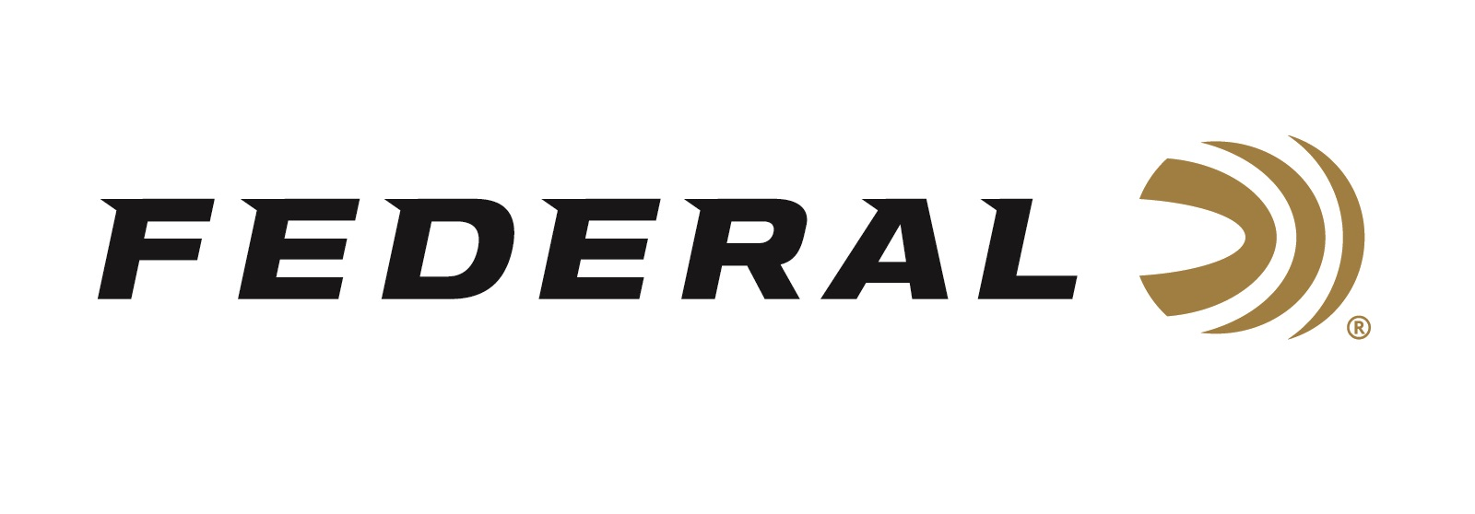
Contact: JJ Reich
Communications Manager
Firearms and Ammunition
(763) 323-3862
FOR IMMEDIATE RELEASE E-mail: pressroom@vistaoutdoor.com
December 10, 2018

U.S. Department of Homeland Security (DHS) Awards Federal Ammunition a .223 Remington Ammunition Contract

ANOKA, Minnesota – Federal Ammunition was recently awarded a major contract from the U.S. Immigration and Customs Enforcement (ICE). Starting delivery in 2019, the multi-agency contract (MAC) provides for up to $75 million of .223 Rem duty ammunition to multiple Department of Homeland Security law enforcement components and other federal agencies for up to five (5) years. This contract will provide the organization’s agents and officers with .223 Rem duty and training ammunition.

“We are proud to provide the highest quality duty ammunition to DHS agents in the field,” said Federal Ammunition President Jason Vanderbrink. “Officers in the field require the highest quality ammunition at their disposal, in their vigilant fight to protect our freedoms. Federal Tactical ammunition ensures the highest performance threshold, and absolute officer confidence in terminal performance.”
Federal Tactical is a trusted partner for some of the most intense conditions encountered by law enforcement. It achieves accuracy and terminal performance that defeats tough barriers with minimal deviation. The ammunition utilizes the highest quality Federal brass, projectiles and primers. Service to training, full-autos to patrol rifles, Federal Tactical offers outstanding technical performance and value.
ICE, which was created in 2003, is tasked with promoting homeland security and safety, as well as enforcing federal laws governing border control, immigration, customs and trade. The agency has more than 20,000 employees in more than 400 stateside offices and 46 foreign countries. Its annual budget is roughly $6 billion. ICE executes its mission through the enforcement of more than 400 federal statutes, and focuses on immigration enforcement, terrorism prevention and combating the illegal movement of people and trade.
Federal Ammunition - is a brand of Vista Outdoor Inc., an outdoor sports and recreation company. For more information on Federal ammunition, go to www.federalpremium.com.

###

